
Pax Place - Holiday Let

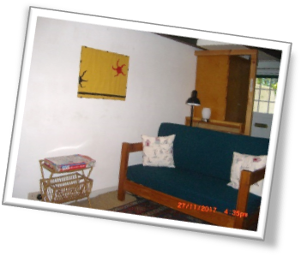
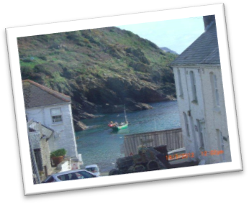
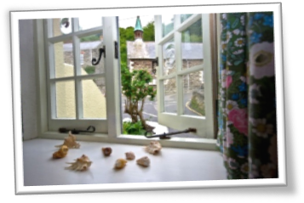
Pax Place, Portloe, Cornwall, TR2 5QX

2018 - Particulars, Terms and Conditions

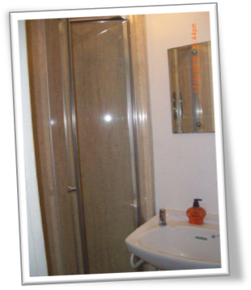
Pax Place…

Enjoy a cup of tea or evening drink looking out at the harbour before walking to the Lugger or Ship for an evening meal and sleep peacefully in the bedroom overlooking the Jacka and cliffs with the stream alongside without being disturbed by early morning delivery vehicles. You are so close to the sea there is no excuse not to take an early morning swim before breakfast and enjoying the view before setting off for the day. Pax Place is tucked away opposite the Church in the centre of Portloe and entered through the dark blue door.

Arrival/Departure: Friday. Linen provided. No towels or beach towels.

Equipment: Refrigerator/freezer, microwave/oven, electric hob, washing machine, kettle, toaster, TV with DVD, radio, books, cards and board games. Electric thermostatically controlled wall panel heaters.

Parking between Pax Place and the harbour. There is a car park about 5 minutes walk away.

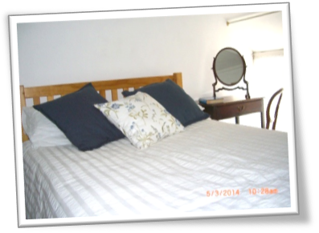
Directions…

By Car: From Tregony follow signs to Veryan/St Mawes until petrol
station and shop where you fork left. Continue until sign to Portloe to
left. Keep on the road down the hill and continue past car park to Church and
phone box on your right. Pax Place is the dark blue front door opposite.

By Train and Bus: To Truro and occasional bus to Portloe.

By Plane: to Newquay.
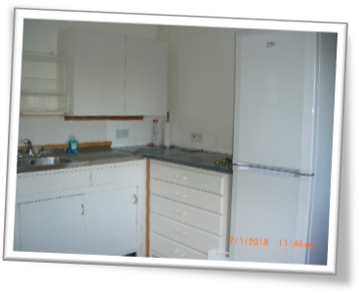
Local Area…
- Swim in Portloe harbour or nearby Carne/Pendower beach.
- Walk the costal path passing the door and other footpaths
- Eat out in Portloe at the Ship, Lugger Hotel or nearby at the Nare Hotel.
- Explore National Trust and other properties and gardens
- Food and Petrol Buy newspapers and shop at Texaco garage (passed on
your way to Portloe) or close by in Veryan and Tregony.
- Bus stop to Truro outside the Church opposite front door.

Terms & Conditions...
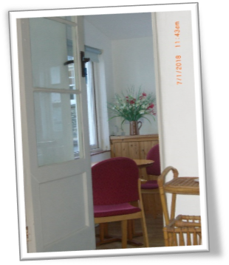
Accommodation for 1 or 2 adults. Sorry, no children or smoking. Small well-behaved dog welcome at £25.00 a week.

Week commences 3.30pm on the first Friday of your holiday and ends at 10am on the Friday of your departure.

Deposit: £100.00
Payment: Due four weeks before your holiday starts. Non-payment of the balance of the rent by the due date shall be construed as a cancellation of the contract. If Pax Place cannot be re-let you will be responsible for the full cost of the holiday. If Pax Place unavailable due to circumstances outside my control the rental money received will be returned.

Key: Arrangements will be posted on completion of payment for holiday let together with an inventory.

Please check when you arrive and let me know of any missing items or breakages. Complaints cannot be accepted after the tenancy has ended.

Small dog not allowed in bedroom or on the furniture and any dog fouling to be removed immediately.

The hirer is responsible for any loss or damage to the property (reasonable wear and tear excluded), for taking good care of Pax Place and leaving it in a clean and tidy condition. Should it be found that an excessive amount of cleaning is required a charge will be made.

Electricity is included in the rent except in low season 1 October to 1 May. Broadband may be accessed through BT Fon. All information is given in good faith and no responsibility taken for any errors or omissions.


Contact details and 2018 prices …
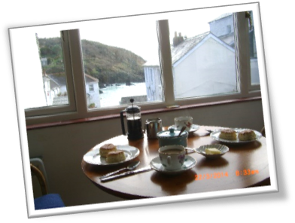
Dates | * Price for 7 nights (£)
Friday 27 April to 24th May | £500.00
Friday 25th May to 28th June | £575.00
Friday 29 June to 26 July | £625.00
Friday 31 August to 4 October | £550.00
Friday 5 October to 1 November | £440.00

* Please add an additional £25 per week when bringing a small well-behaved dog.

Please contact me on the details below for further information about Pax Place or to confirm availability
(Remember to state the planned date of your visit and duration):

Email: jenpax1@yahoo.co.uk
Telephone: 01386 840272

Post: Mrs A. J. Kissel, Garden Cottage, Chipping Campden, GL55 6AL



Please complete the form and send with cheque by post, or email for bank details:

Name(1): ....................................................................................................................................................................
Name(2) .....................................................................................................................................................................
Address:......................................................................................................................................................................
………………………….........................................................................................................................................................
............................................................................................. Postcode: ............................................................
Telephone Number: …………………………….............….............. Mobile Number: .................................................
Email: .................................................................................. Nationality...........................................................
Date from: Friday ........................................................... 2018 Dog. Breed............................................. £25.00 per week
Date to: Friday............................................................ 2018
Deposit: £100.00
Signed (1): ......................................................................................... Date: …………………………………………........ 2018
Signed (2): ……………………………………………........................................... Date: … ……………..……..…...................... 2018

